Section A: Website Planning & Documentation

**1. Website Specifications**

a. Objective & Goals

Objective: Reimagine Warner Bros. website as a modern and user-friendly hub for showcasing their diverse entertainment offerings.

Goals:

* Increase user engagement with compelling content and interactive features. For more easier usage with minimal intervention.
* Enhance brand awareness by creating a visually appealing and consistent experience. For a more well known website that people feel comfortable to use and interact well with.
* Improve user experience by providing intuitive navigation and accessibility across devices. It should be literate for all users.

b. Target Audience

* Demographics: Moviegoers, TV viewers, gamers, animation enthusiasts (broad age range).
* Technical Aptitude: Varied audience with basic to moderate technical skills.

c. Website Type

Informational and Entertainment Portal with E-commerce elements (for the "Collections" page).

**2. Information Design & Taxonomy:**

Site Map:

A visual representation of the website structure will be created, outlining the following pages:

Home (Index Page)

Movies (with individual movie pages)

TV Shows (with individual TV show pages)

Games & Apps (with individual game/app pages)

Collections (featuring merchandise)

Feedback (with an HTML form)

**3. Page Template Design:**

Wireframes:

Low-fidelity wireframes are created using Figma to define the basic layout and placement of elements on each page (navigation, content sections, multimedia objects).

Visual Designs:

Utilizing GIMP, high-fidelity mockups will be developed for each page template, incorporating branding elements, color schemes and imagery for a cohesive and visually appealing interface.

**4. Technical Brief :**

Technologies:

* HTML5 for website structure and content.
* CSS3 for styling and visual design.
* JavaScript for interactive elements and dynamic features.
* Bootstrap framework for pre-designed components, responsiveness, and simplified development.

Resources:

* Text editor (Notepad) for coding HTML, CSS, and JavaScript.
* GIMP for image editing and graphic design.
* Figma for creating wireframes.
* Gloomaps for visualizing sitemap <https://www.gloomaps.com/>

**5. Quality Assurance:**

A detailed testing plan was be implemented to ensure website functionality and compatibility:

* Cross-browser testing: Chrome, Firefox, Safari

TESTING ON MICROSOFT EDGE

* A computer screen shot of a boot

  Description automatically generated

TESTING ON CHROME

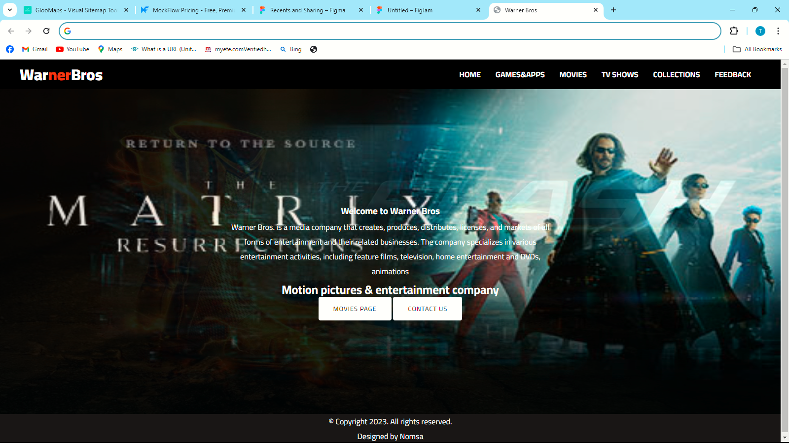

* Device responsiveness testing: Verify website displays correctly on desktops, tablets, and mobile devices.

The following shows my website tested on Samsung Galaxy

The following shows my website tested on pixel 7

**6. Publishing & Promotion:**

The website will be hosted on GitHub Pages.

The final website link: <https://github.com/TassMaropefela/fbda23-013>

**7.Future developments**

**Enhancing User Experience (UX):**

* Add interactivity: Implement JavaScript or a framework like React.js to create dynamic elements and improve user engagement.
* Refine mobile responsiveness: Test your website thoroughly on various devices and screen sizes to ensure optimal viewing experience.

Content & Functionality:

* Integrate a blog or CMS (Content Management System): Allow for easier content creation and updates without needing to directly modify website files.
* Incorporate analytics: Use tools like Google Analytics to track website traffic, user behavior, and identify areas for improvement.
* Embrace SEO best practices: Optimize website content and structure for search engines to increase organic discovery.

Advanced Features:

* Embrace custom domain: Replace the default GitHub Pages URL with a more memorable custom domain name.
* Implement forms and user authentication: Allow for user interaction through forms (contact, feedback, etc.) and consider user account functionality if applicable to your website's purpose.
* Explore continuous integration/delivery (CI/CD): Automate website building and deployment processes for a smoother workflow.